**Assignment 05 – WordPress CMS Website (Basic Pages)**

**Instructions for completing template:**Replace **[bracketed red text]** with the requested information or screen capture.  
Replace **bracketed red text with black text** and then remove the brackets.  
Do not include full screen shot images, or full screen shots that are reduced in size. Use a snippet tool to capture parts of the screen and insert those images into the template.  
Do not remove tags from this template. Please answer all questions.  
**Please do not alter the formatting or delete parts of this template.**  
Assignment questions are not as detailed as activity questions.   
The assignment is where you demonstrate understanding of the material.

**Part A - Student Information**

1. **Student Name: [SYED AFTAABUDDIN] [A01]**
2. **Student Email: [syedaftab299@gmail.com] [A02]**
3. **Student Phone: [773-796-0029] [A03] *Optional**

**Go back to the instructions and begin work on Part B.**

**Part B – Select Platform Credentials**

1. **[B01] Credentials for the selected and used Platform**
   1. Shared Web Host Platform Credentials:
      1. Shared Web Host Name: [Namecheap] [B01.1]
      2. Shared Web Host URL: [Namecheap.com] [B01.2]
      3. Shared Web Host Site Admin Username: [saftaabu] [B01.3]
      4. Shared Web Host Site Admin Password: [50297006@Sps] [B01.4]
   2. Pantheon (PaaS) Platform Credentials:
      1. Pantheon Admin Username: [] [B01.5]
      2. Pantheon Admin Password: [] [B01.6]
   3. Codeanywhere Credentials
      1. Codeanywhere Admin Username: [] [B01.7]
      2. Codeanywhere Admin Password: [] [B01.8]

**Part C – Create one (1) WordPress CMS Website on one (1) Platform of your choosing**

(1) Shared Web Host WordPress CMS Site Information: [C01]

Website Admin Username: [saftaabu] [C01.1]  
Website Admin Password: [%dOhIhi#Em0@\] [C01.2]  
Database Name: [wp748] [C01.3]  
Table Prefix: [wp3y_] [C01.4]  
WordPress CMS Website URL: [http://syedaftab.tech/assignment05/] [C01.5]

-OR- If building on Pantheon…

(2) Pantheon – WordPress CMS Site Information: [C02]

**Assignment Website Site Name:** **[Site Name here] [C02.1]**

**WEBSITE Admin Username:** **[Admin Username here] [C02.2]**

**WEBSITE Admin Password:** **[Admin Password here] [C02.3]**

**Pantheon Frontend Website URL:** **[Frontend website URL here] [C02.4]**

-OR-- If building on Codeanywhere…(3) Codeanywhere – WordPress site on Codeanywhere [C03]

* 1. Site Title: [ site title here ] **[C03.1]**
  2. Username: [ username here ] **[C03.2]**
  3. Password: [ password here ] **[C03.3]**
  4. Take screen captures of the edited .htaccess file **[C03.4]  
     [ Paste screen capture here ]**
  5. Take screen captures of the bottom of the edited wp-config file **[C03.5]  
     [ Paste screen capture here ]**

**Go back to the instructions and begin work on Part D.**

**Part D - Extend the WP Site Content**

1. SCREEN CAPTURE of the backend WordPress **[Dashboard > Home]**For full credit, please make sure the screen capture has the web browser address bar visible as well as the Dashboard Home “At a Glance” panel. **[D01] [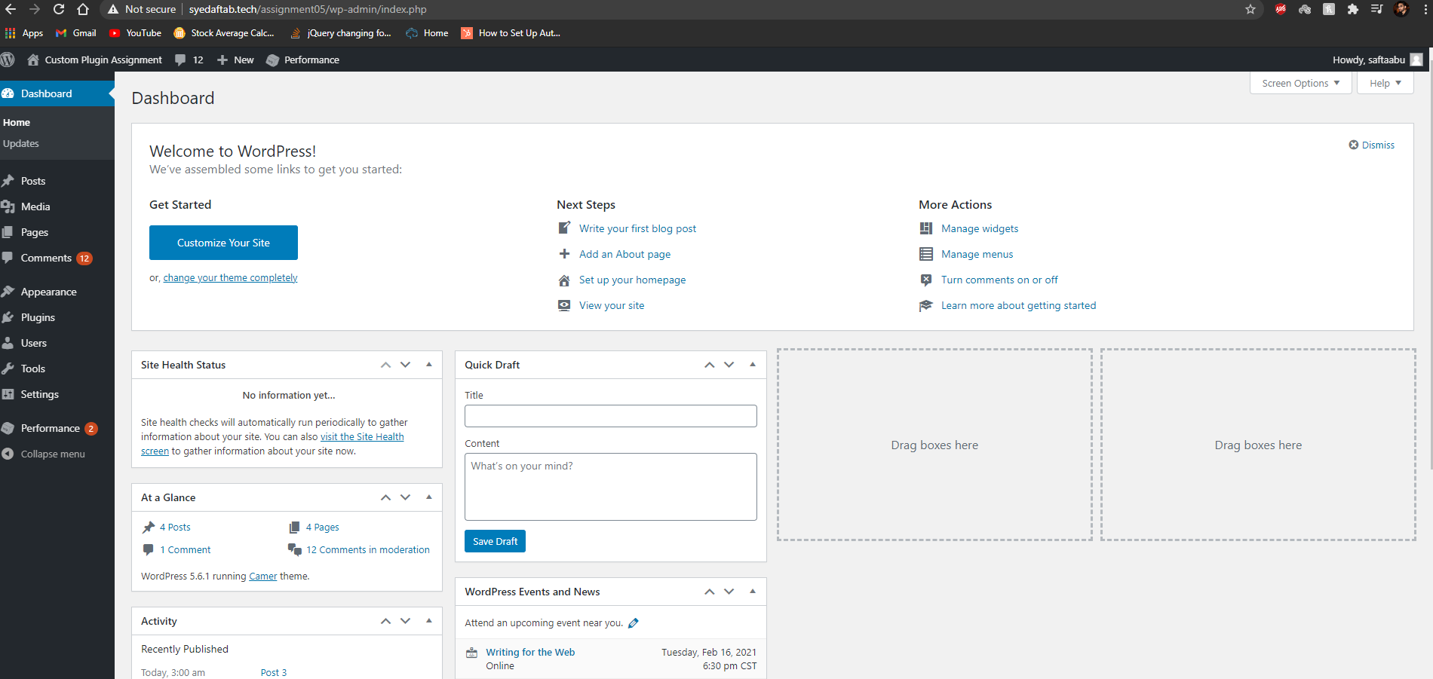]**
2. SCREEN CAPTURE of the backend WordPress **[Dashboard > Appearance]   
   [D02] [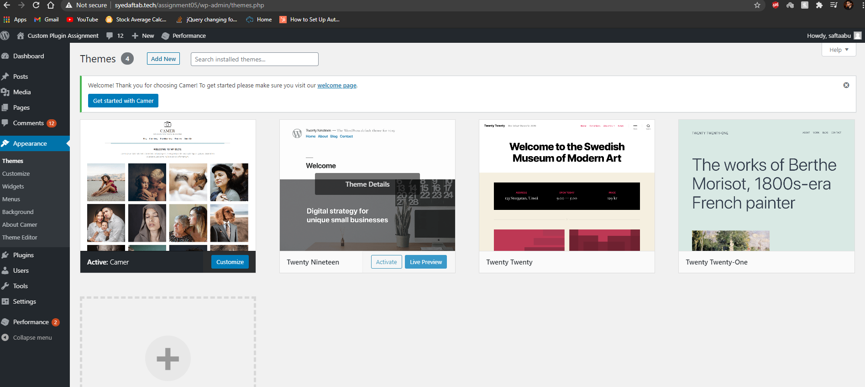]**
3. SCREEN CAPTURE of the backend WordPress **[Dashboard > Appearance > Menus]   
   [D03]  
   [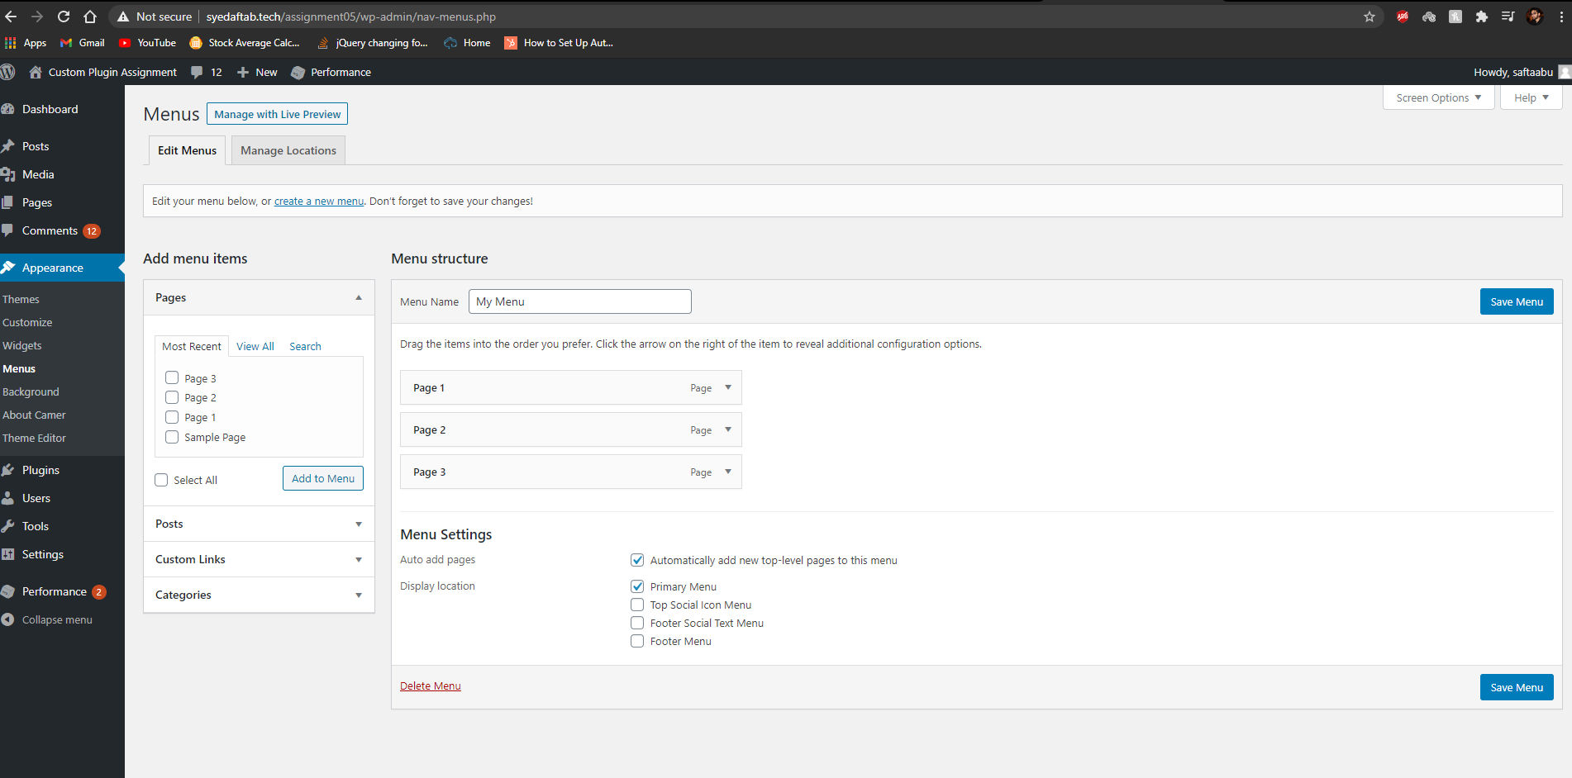]**
4. SCREEN CAPTURE of the backend WordPress **[Dashboard > Pages]   
   [D04]  
   [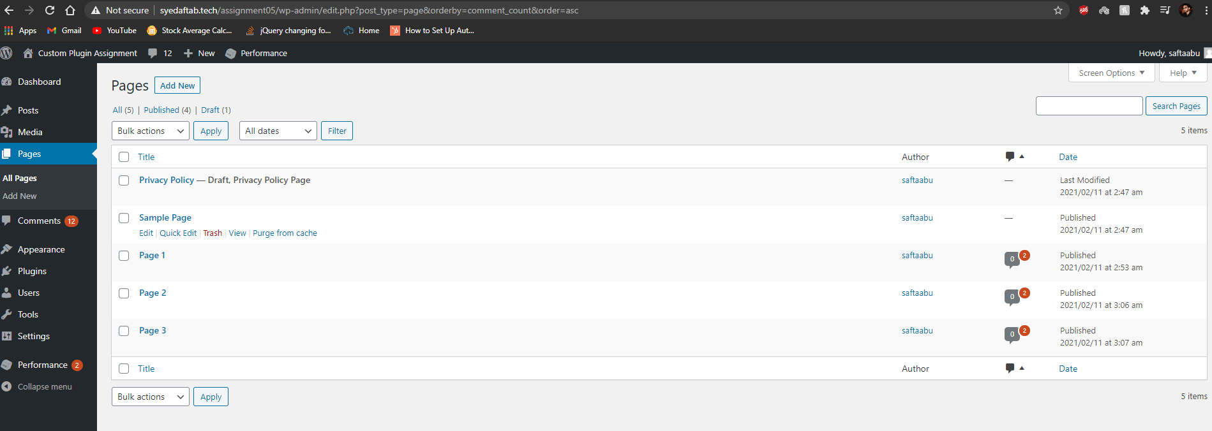]**
5. SCREEN CAPTURE of the backend WordPress **[Dashboard > Posts > Categories]   
   [D05]  
   [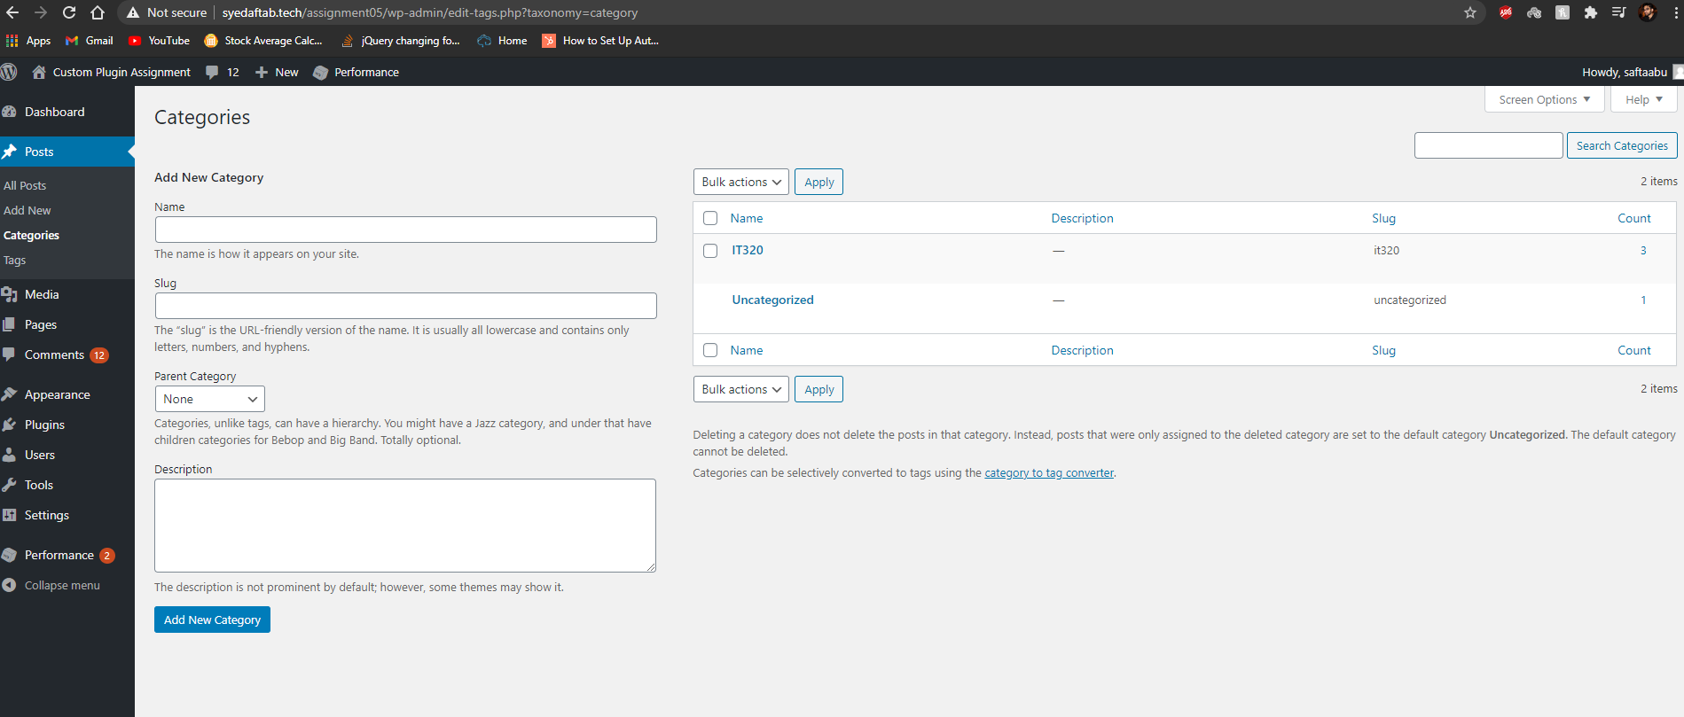]**
6. SCREEN CAPTURE of the backend WordPress **[Dashboard > Posts > Tags]   
   [D06]  
   [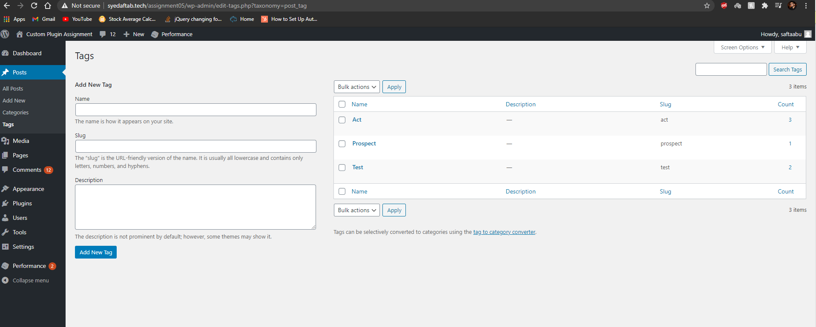]**
7. SCREEN CAPTURE of the backend WordPress **[Dashboard > Posts]   
   [D07]  
   [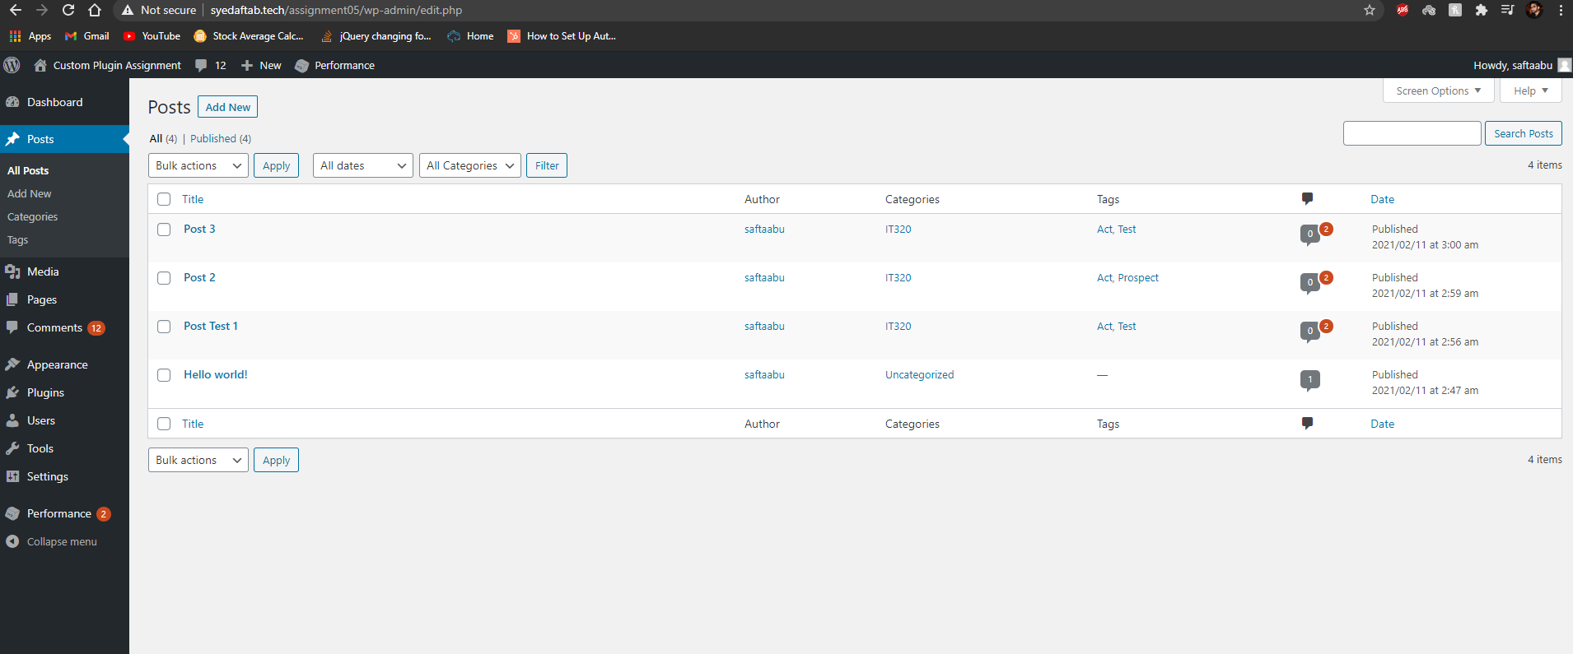]**

**Go back to the instructions and begin work on part E.**

**Part E - Create and deploy a WordPress Custom Plugin – Posts Reader**

**1. Take a** SCREEN CAPTURE of the **backend** **[Dashboard > Plugins]   
[E01]  
[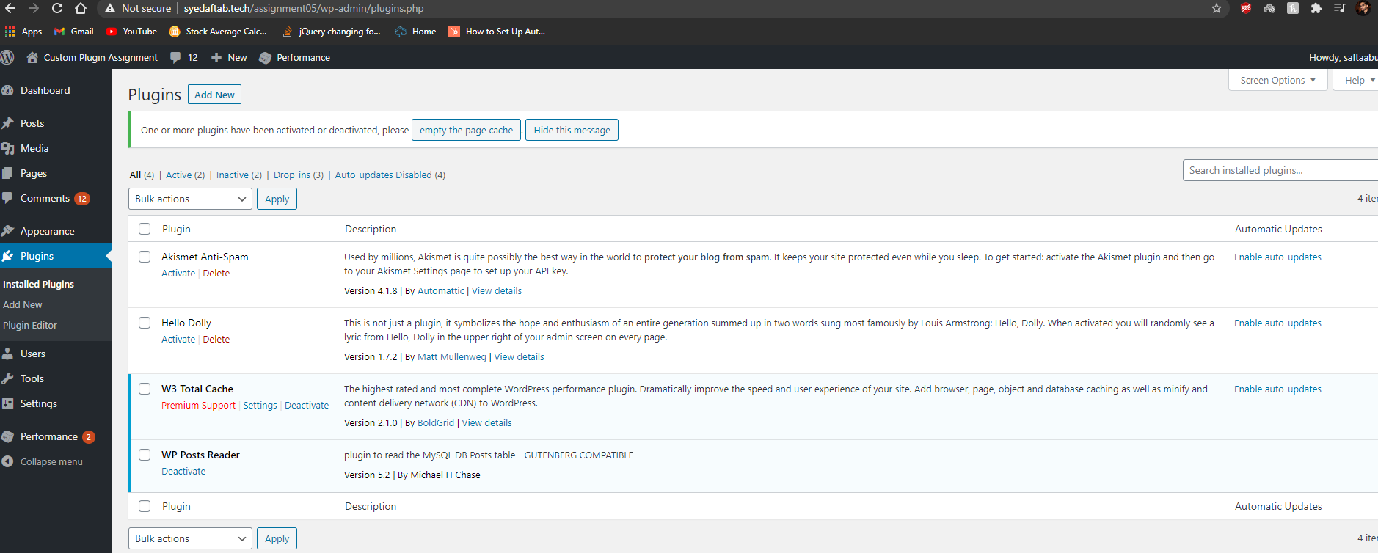]**

**2. Take a** SCREEN CAPTURE of the **backend** **[Dashboard > Appearance > Menus]   
[E02]  
[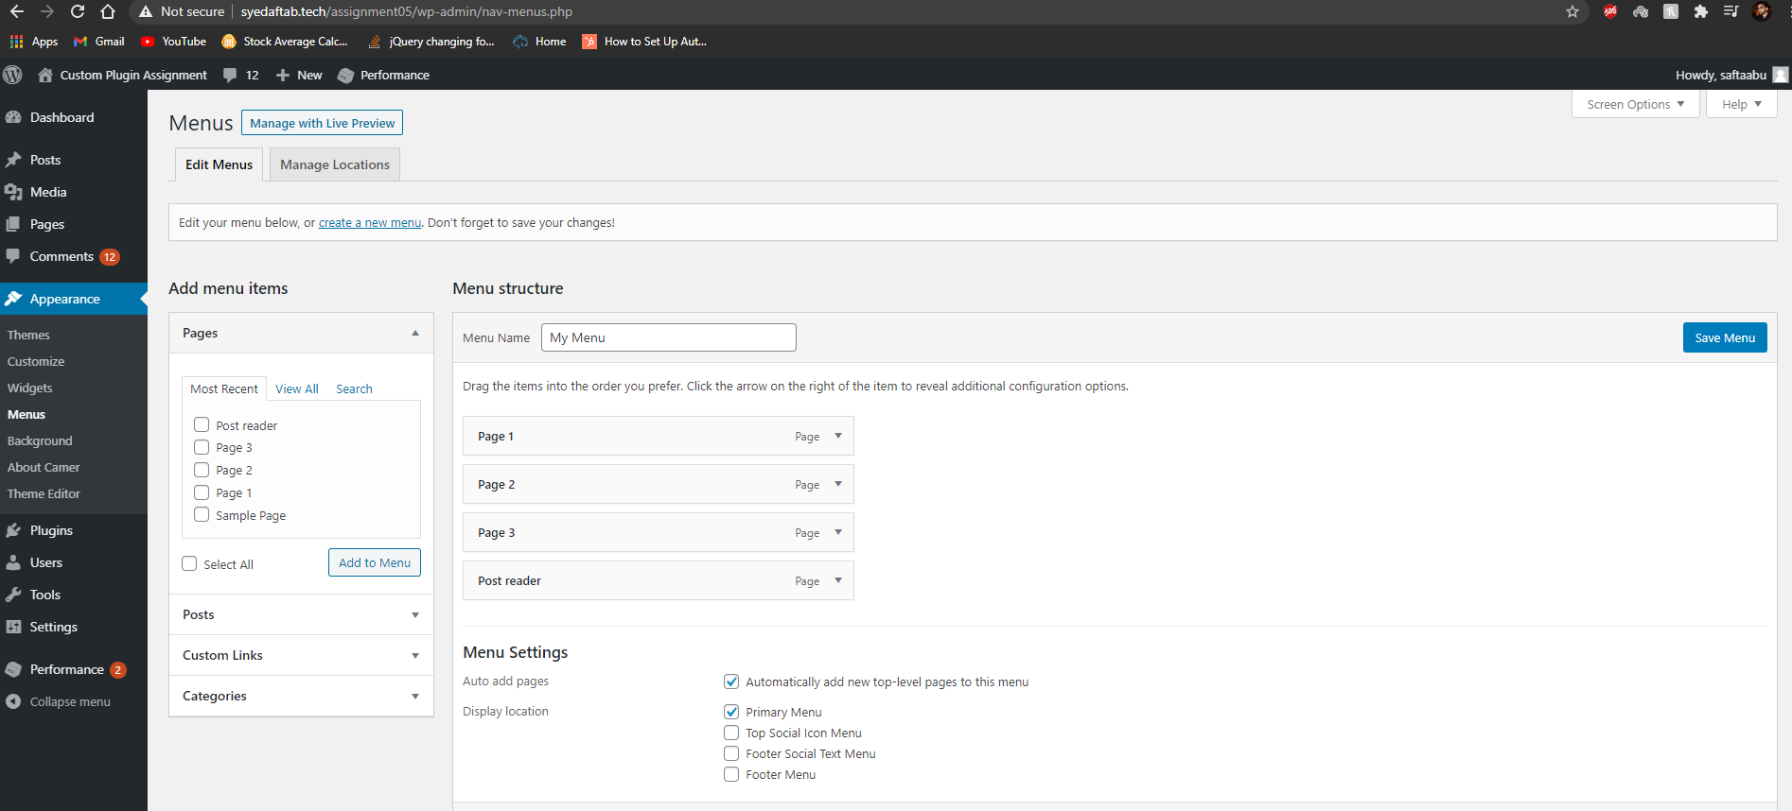]**

**3.** SCREEN CAPTURE of the **custom Plugin code [the entire plugin file contents]   
[E03]  
[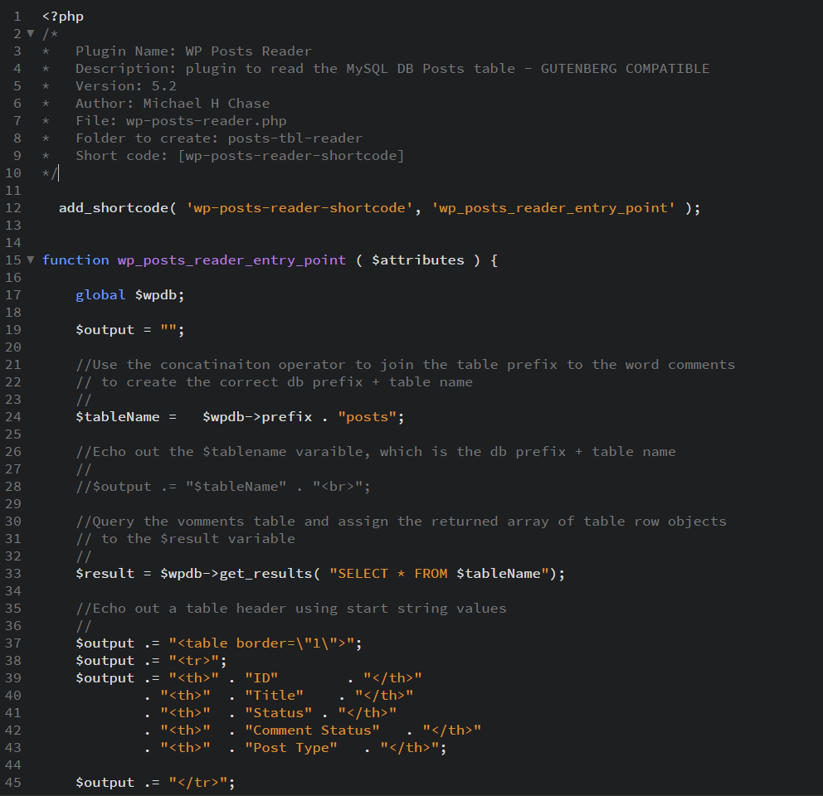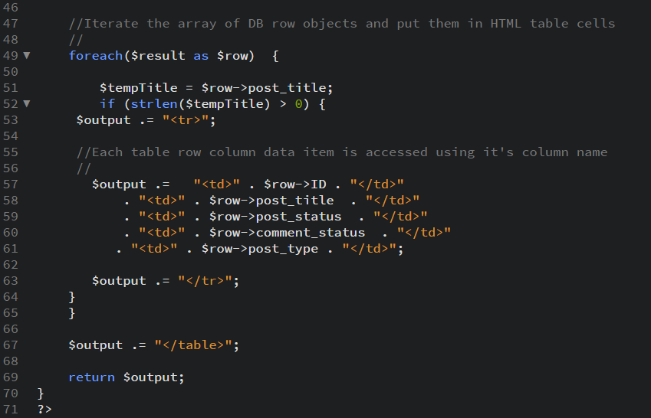]**

**4. SCREEN CAPTURE of the frontend** of the website showing your working custom plugin selected form the menu **[E04]  
[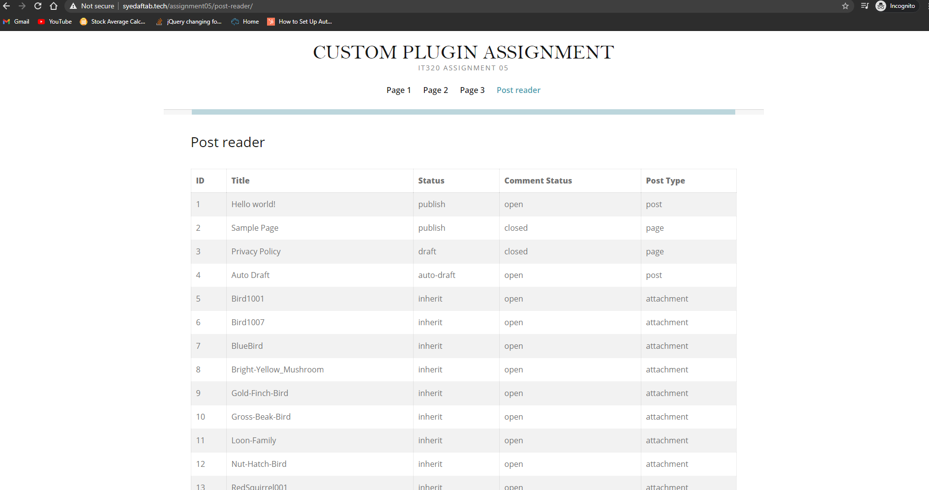]**

**Go back to the instructions and begin work on part F.**

**Part F - Create and deploy a WordPress Custom Plugin - Terms**

**1. Take a** SCREEN CAPTURE of the **backend** **[Dashboard > Plugins]   
[F01]   
[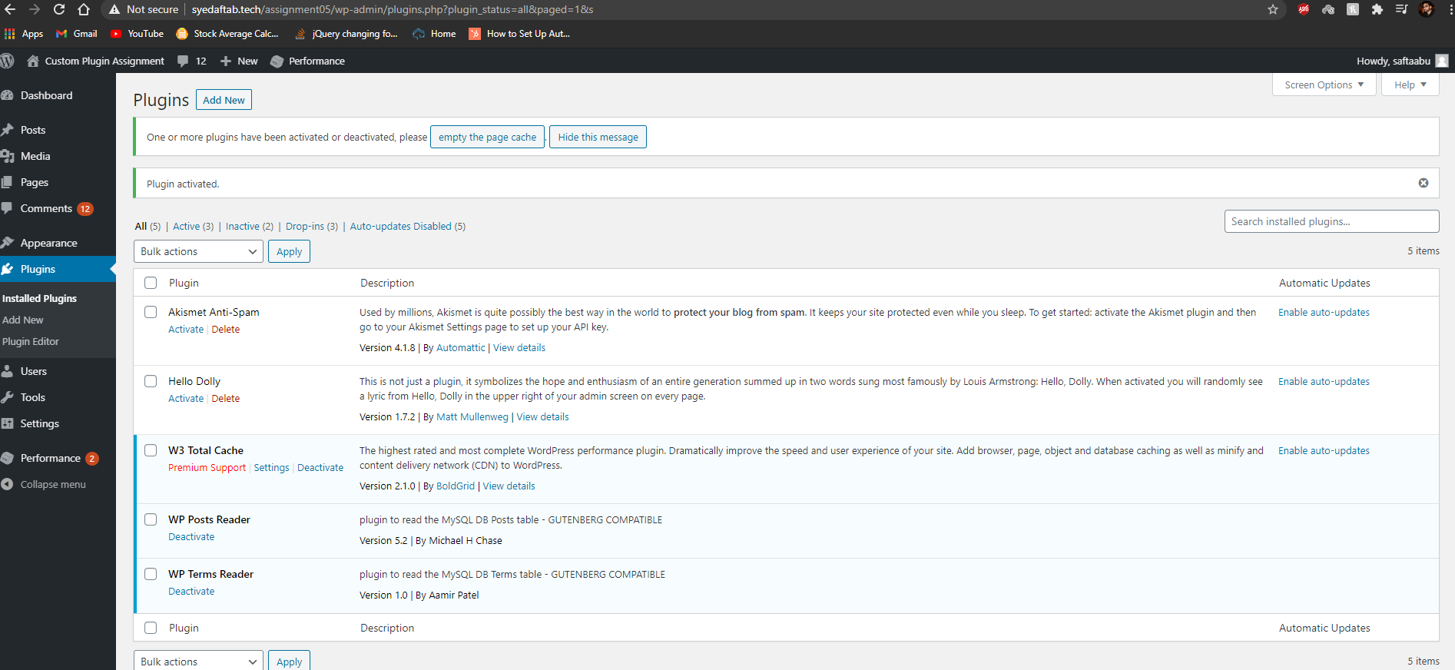]**

**2. Take a** SCREEN CAPTURE of the **backend** **[Dashboard > Appearance > Menus]   
[F02]   
[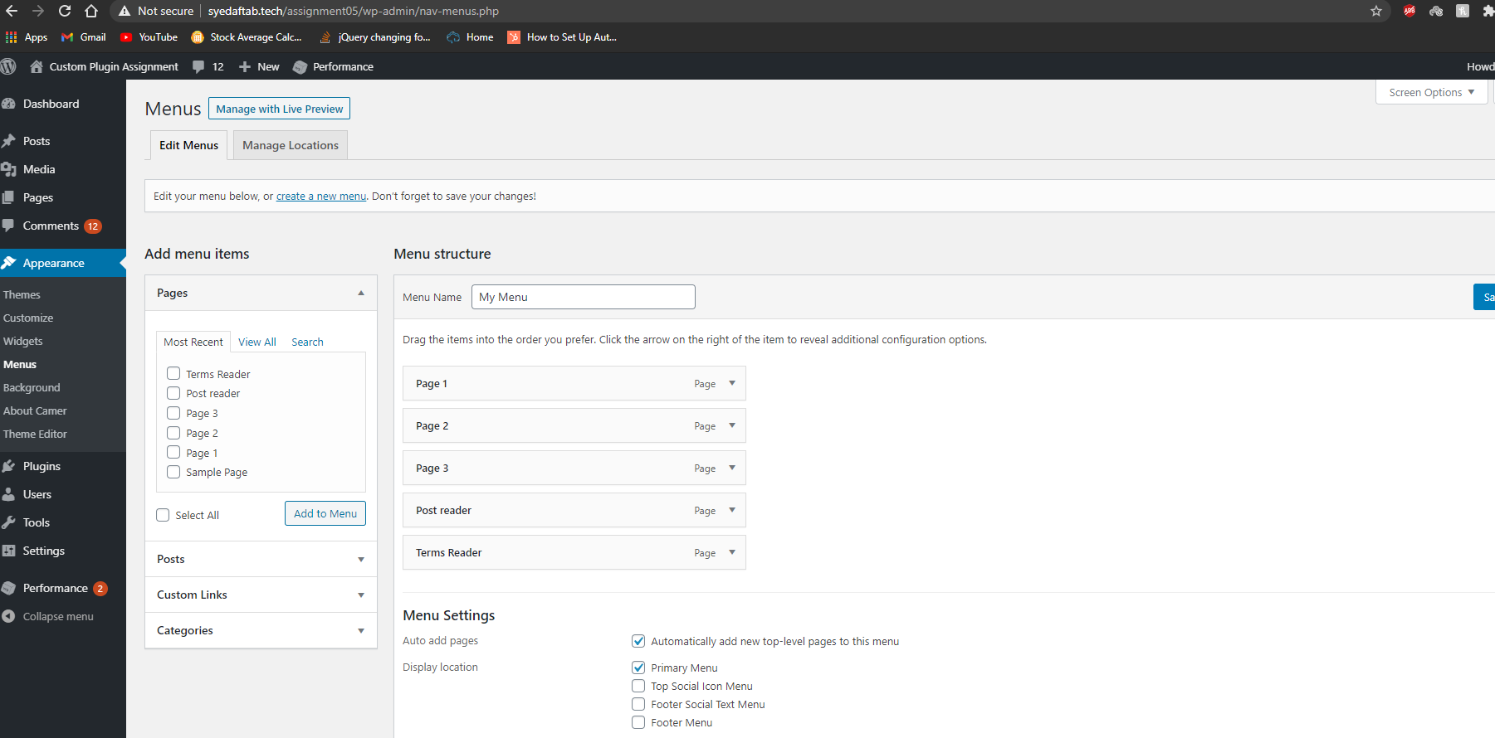]**

**2.** SCREEN CAPTURE of the **custom Plugin code [the entire plugin file contents]   
[F03]   
[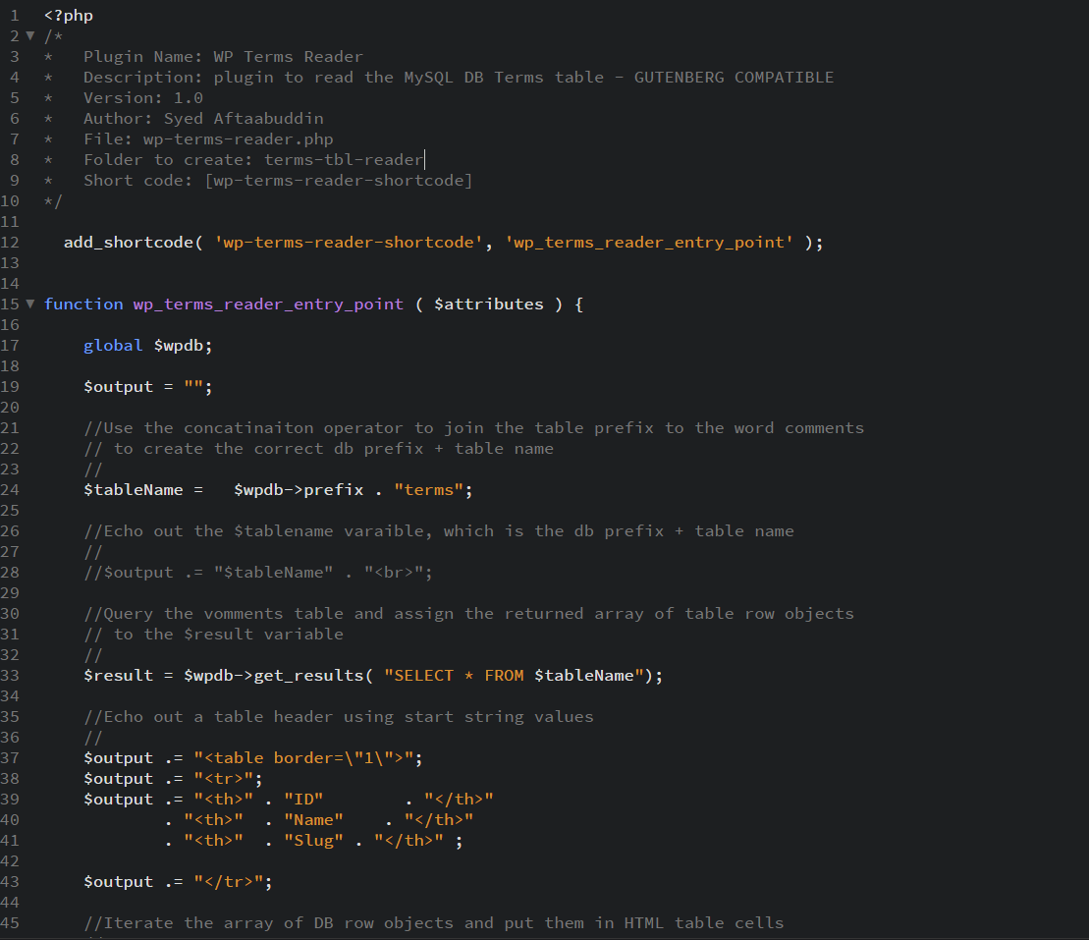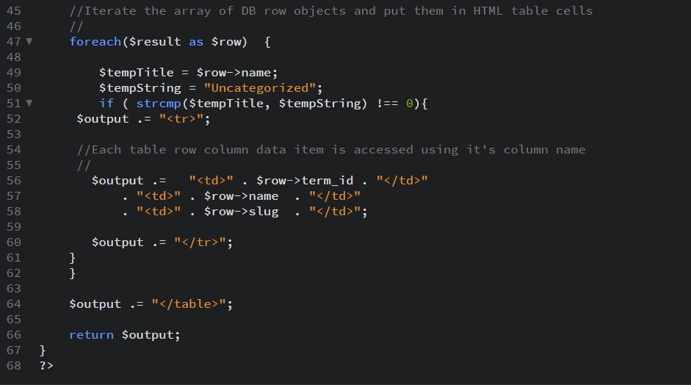]**

**3. SCREEN CAPTURE of the frontend** of the website showing your working custom plugin selected from the menu **[F04]   
[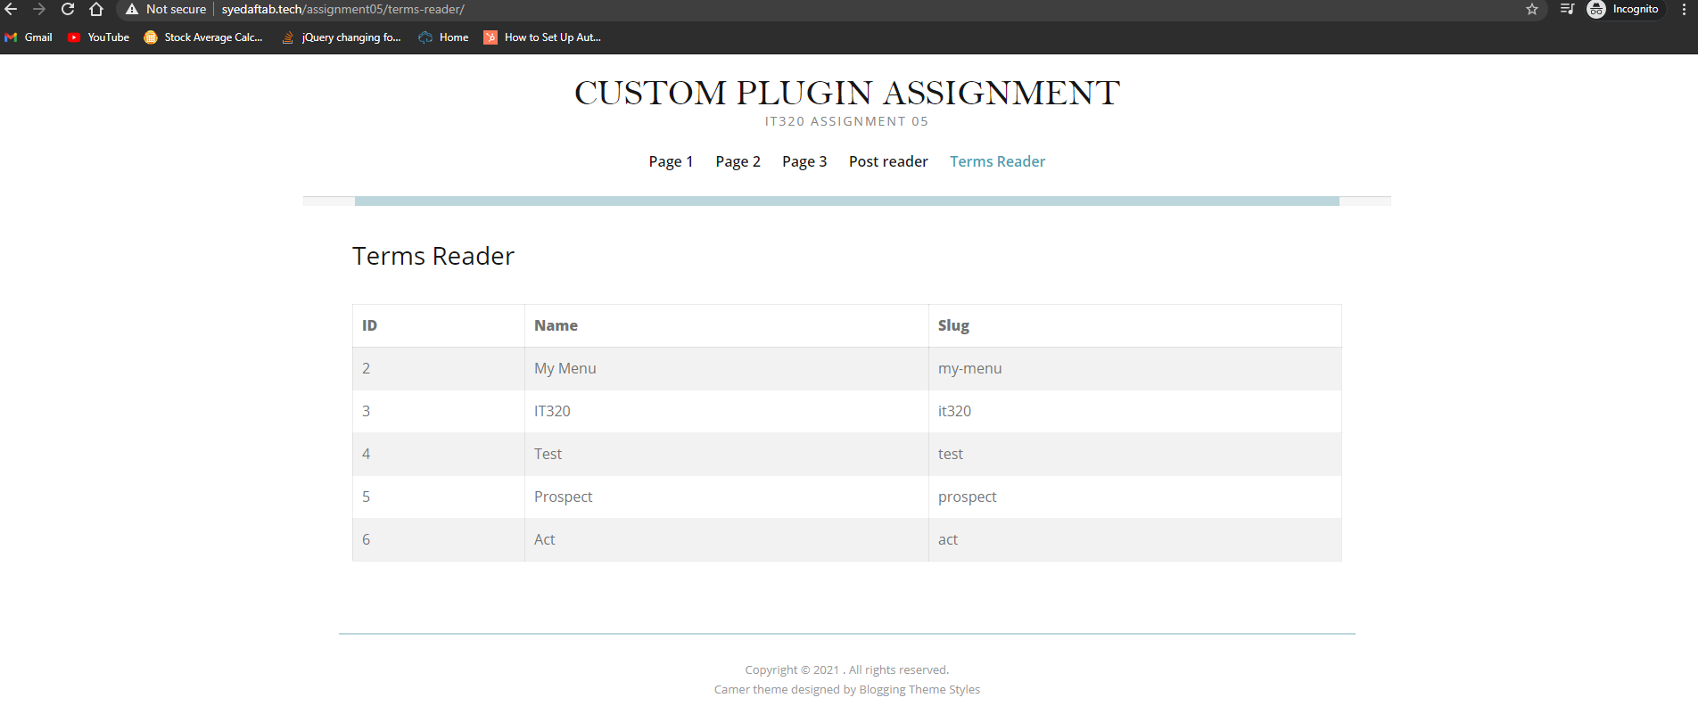]**

**Go back to the instructions and begin work on Part G.**

**Part G - Create and deploy a WordPress Custom Plugin - Taxonomy**

**1. Take a** SCREEN CAPTURE of the **backend** **[Dashboard > Plugins]   
[G01]   
[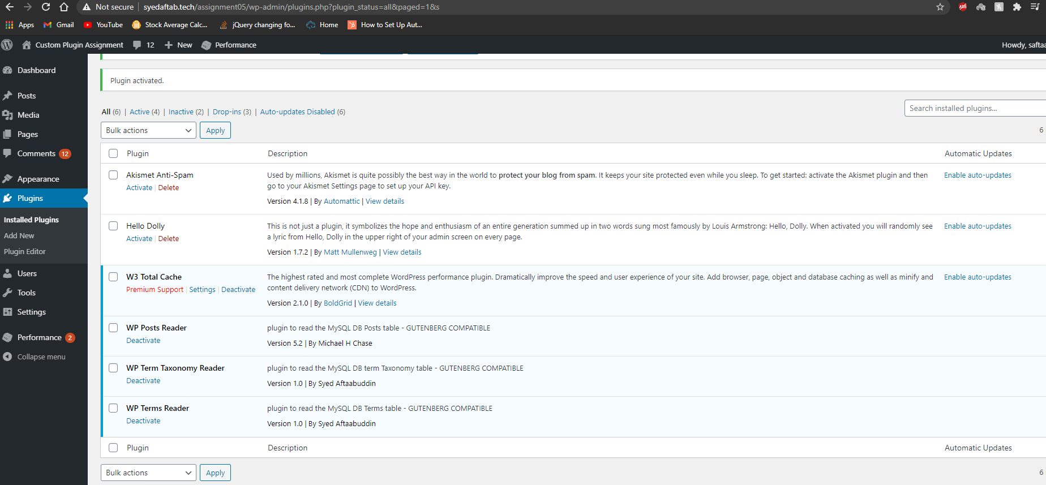]**

**2. Take a** SCREEN CAPTURE of the **backend** **[Dashboard > Appearance > Menus]   
[G02]   
[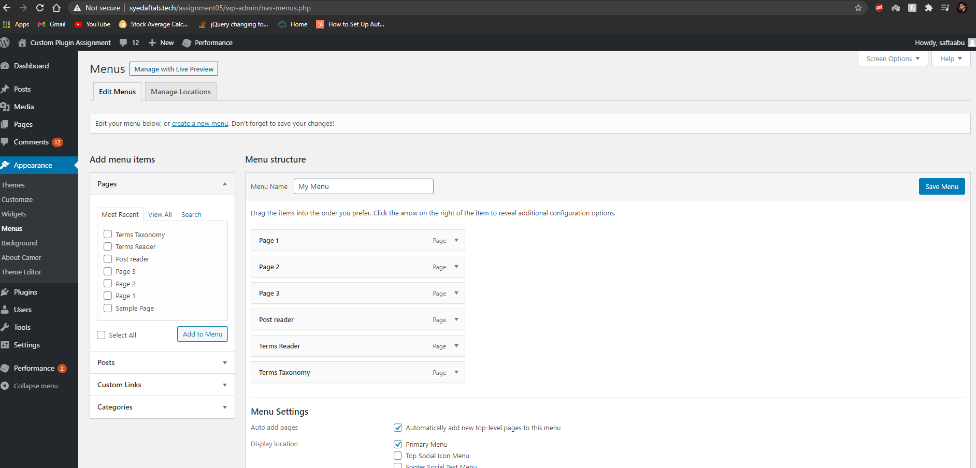]**

**2.** SCREEN CAPTURE of the **custom Plugin code [the entire plugin file contents]   
[G03]   
[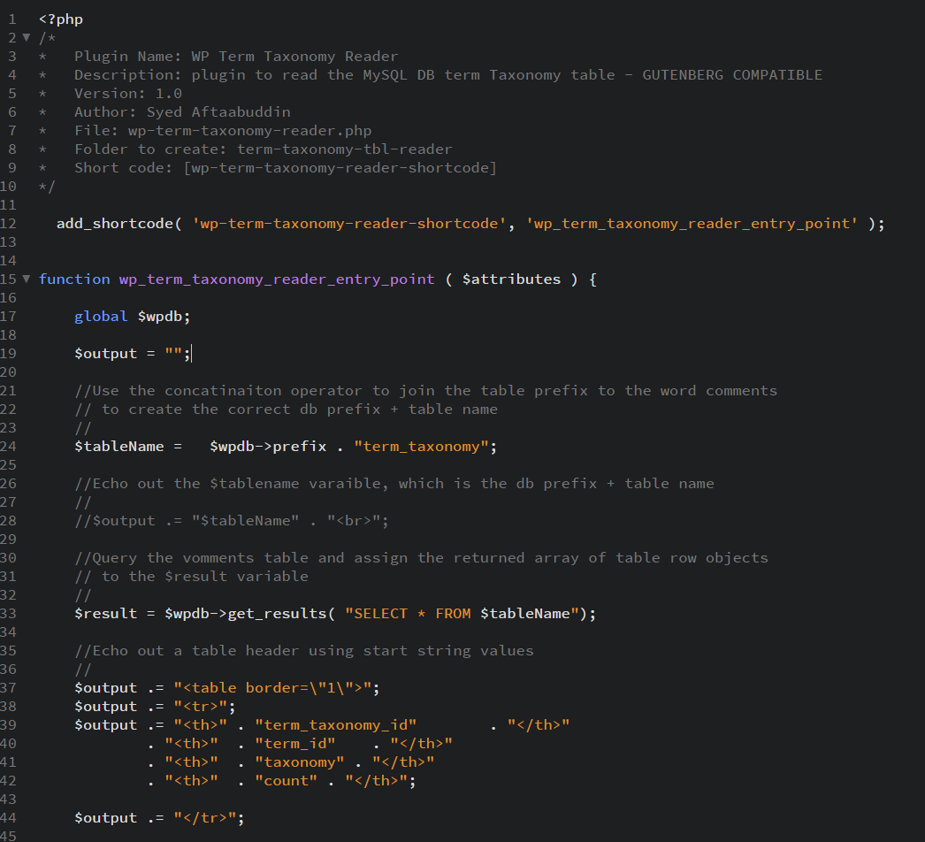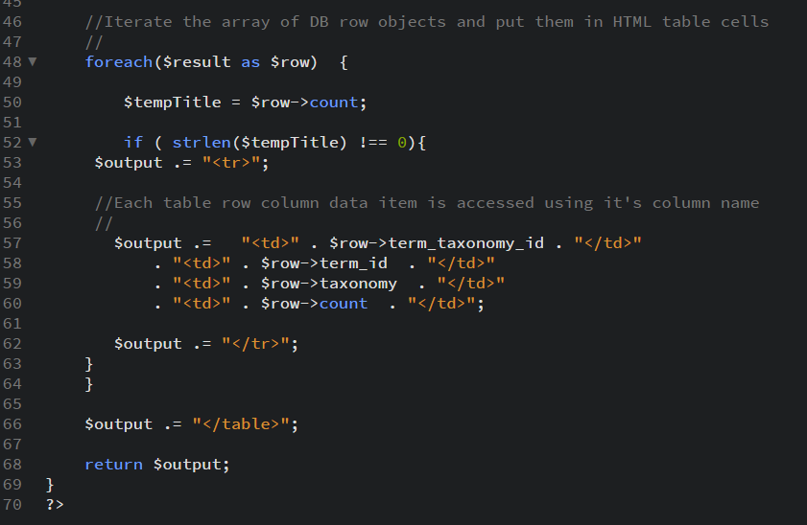]**

**3. SCREEN CAPTURE of the frontend** of the website showing your working custom plugin selected form the menu  
**[G04]  
[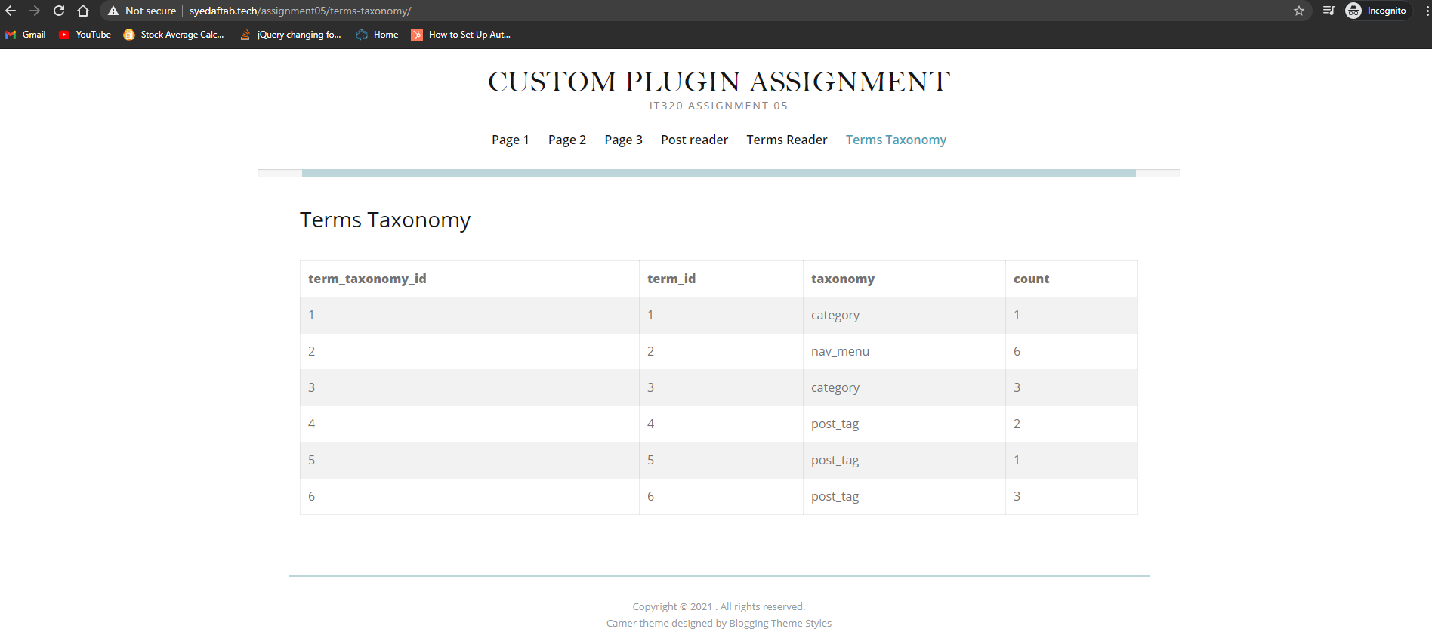]**

**Go back to the instructions and begin work on Part H.  
  
Part H – Assignment Wrap up:**

1. **Did you have any problem or issues completing this assignment?  
   This is not an optional question. Please answer yes if you had issue or left one or more parts empty.  
   [No] [H01]  
     
   If you answered yes to this question, please elaborate and be specific.  
   If you had trouble with a specific question, please identify it by number and explain what you did not understand or had problems with.  
   I can only improve this assignment with your help.**

**[List problems here]   
[H02] *Only if you answered yes above in [H01]**

Submit this completed template to the correct D2L assignment dropbox.If you prefer not to navigate by hand to the D2L dropbox, take advantage of the dropbox link in the D2L this module’s section. This link will take you to the correct assignment dropbox location.